**NANDHA COLLEGE OF TECHNOLOGY**

**ERODE- 638 052**



**DEPARTMENT OF INFORMATION TECHNOLOGY**

**GE3451 – ENVIRONMENTAL SCIENCES AND SUSTAINABILITY**

(Regulations 2021)

**FOURTH SEMESTER**

(ACADEMIC YEAR 2022-23)

**ASSIGNMENT / CASE STUDY REPORT – I**

**INDUSTRY THAT POLLUTE AIR**

|  |  |
| --- | --- |
| **REGISTER NUMBER** | **732121205016** |
| **NAME OF THE STUDENT** | **C.K.DHARUN** |
| **SUBMITTED ON** |  |
| **MARKS OBTAINED** |  |
| **STAFF SIGN WITH DATE** |  |

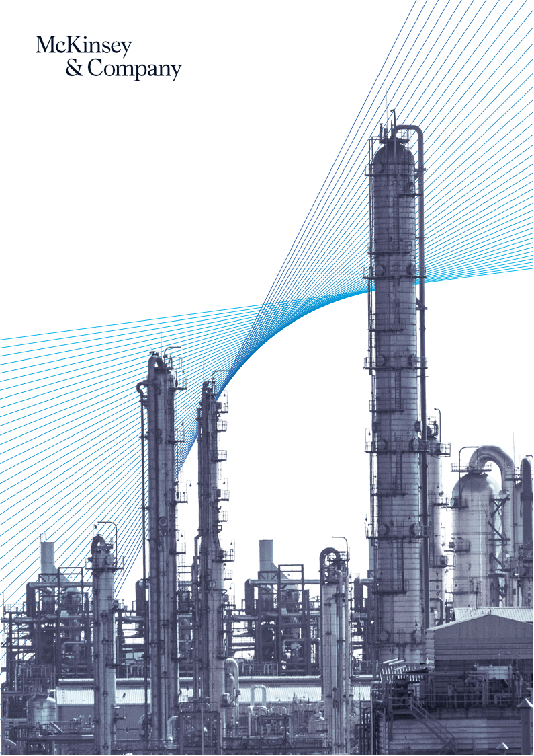

**AIR POLLUTION: CHEMICAL INDUSTRY IN INDIA**

# **CONTENT:**

1. **Introduction**
2. **Source of Air pollution**
3. **Chemical Industries in India**
4. **Problems affect due to Chemical Industry**
5. **Recommendation**
6. **Conclusion**

**1.INTRODUCTION**:

The chemical industry plays a vital role in global economic development and technological innovation. However, it also has significant environmental impacts, including air pollution. This case study focuses on the chemical industry's impact on air quality in a specific region.

India is home to a large and growing chemical industry, with over 40,000 registered chemical manufacturing units. These industries contribute significantly to the country's economy but also pose a major threat to the environment and public health due to their potential to generate large amounts of pollution, including air pollution. This paper examines the sources and impacts of air pollution due to the chemical industry in India, as well as measures that can be taken to reduce or mitigate this pollution.

The Indian chemical industry mainly produces basic types of chemicals as well as knowledge type chemicals and specialty type chemicals as of 2018. India was the largest state contributor to the chemical industry of India in 2018. India also produces products related to petrochemicals ,fertilizer, paints ,Varnishes, paints, perfumes, toiletries , etc.. The India chemical industry is divided into six sub-segments. These sub-segments are Basic Organic Chemicals, Specialty Chemicals, Chlor-alkali, Pesticides, Dyestuff, and alcohol-based chemicals. India is a major producer of basic organic chemicals.

# **2.Source of Air pollution from the Chemical Industry :**

Chemical manufacturing processes can generate a variety of air pollutants, including gases, vapors, and particulate matter. Some of the key sources of air pollution from the chemical industry in India include:

* Volatile organic compounds (VOCs): These are organic chemicals that can evaporate at room temperature, and they can be emitted from various chemical manufacturing processes. Some common VOCs include benzene, toluene, and xylene, which are known to have adverse health effects.
* Nitrogen oxides (NOx): These are gases that can be emitted during various chemical manufacturing processes, particularly those involving combustion. NOx is a key contributor to the formation of ground-level ozone and particulate matter.
* Sulfur dioxide (SO2): This is a gas that can be emitted from various chemical manufacturing processes, particularly those involving sulfur-containing compounds. SO2 is a key contributor to acid rain and can also have adverse health effects.
* Particulate matter (PM): This is a mixture of small particles and liquid droplets that can be emitted during various chemical manufacturing processes, particularly those involving combustion. PM can have adverse health effects, particularly when inhaled into the lungs.

|  |  |  |  |  |
| --- | --- | --- | --- | --- |
| **Sl.**  **No.** | **Name of Company** | **Head Office** | **Display(logo)** | **Website** |
| 1 | Affcil Industries | Pune |  | [www.affcil.com](http://www.affcil.com/) |
| 2 | Nitrex Chemicals  India Ltd. | Ahmedabad |  | [www.nitrex.in](http://www.nitrex.in/) |
| 3 | Tagros Chemicals  India Ltd. | Chennai |  | [www.tagros.com](http://www.tagros.com/) |
| 4 | Indofil Industries  Limited | Mumbai |  | [www.indofilcc.com](http://www.indofilcc.com/) |
| 5 | Tata Chemicals | Mumbai |  | [www.tatachemicals.com](http://www.tatachemicals.com/) |
| 6 | Gujarat Heavy Chemicals Ltd. | Uttar Pradesh | GHCL India | [www.ghcl.co.in](http://www.ghcl.co.in/) |
| 7 | Aarti Industries  Limited | Maharashtra | Manufacturers & Exporters of Agrochemicals, Bulk Drug Intermediates : Aarti Industries Ltd | [www.aartigroup.com](http://www.aartigroup.com/) |
| 8 | India Glycols  Limited | Uttar Pradesh | http://www.indiaglycols.com/images/logo.gif | [www.indiaglycols.com](http://www.indiaglycols.com/) |
| 9 | Gujarat Alkalies and Chemicals Limited | Gujarat | http://www.gacl.com/public_html/new/images/logo_web.jpg | [www.gacl.com](http://www.gacl.com/) |

**3.Chemical Industries in India:**

|  |  |  |  |  |
| --- | --- | --- | --- | --- |
| 10 | Deepak Nitrite  Limited | Gujarat | http://deepaknitrite.com/images/common/logo.jpg | [www.deepaknitrite.com](http://www.deepaknitrite.com/) |
| 11 | Gujarat FluoroChemicals  Limited | Uttar Pradesh | https://www.gfl.co.in/images/logo.gif | [www.gfl.co.in](http://www.gfl.co.in/) |
| 12 | Pidilite Industries | Mumbai | Pidilite | [www.pidilite.com](http://www.pidilite.com/) |
| 13 | Sudarshan Chemicals India  Limited | Pune | Image result for Sudarshan Chemical Industries | [www.sudarshan.com](http://www.sudarshan.com/) |
| 14 | Aditya Birla Chemicals | Mumbai | http://www.adityabirlachemicals.com/images/logo.jpg | [www.adityabirlachemicals.com](http://www.adityabirlachemicals.com/) |
| 15 | Nirma Limited | Gujarat | Image result for Nirma Limited | [www.nirma.co.in](http://www.nirma.co.in/) |
| 16 | Kanoria Chemicals  & Industries Limited | New Delhi | http://www.kanoriachem.com/templates/kclinternal/images/logo.png | [www.kanoriachem.com](http://www.kanoriachem.com/) |
| 17 | Reliance Limited | Mumbai | Reliance Industries Limited | [www.ril.com](http://www.ril.com/) |
| 18 | United Phosphorus | Mumbai | Logo | [www.uplonline.com](http://www.uplonline.com/) |
| 19 | Gas Authority of  India Limited | New Delhi | logo | [www.gailonline.com](http://www.gailonline.com/) |
| 20 | Chembond  Chemicals Limited | Mumbai | http://www.chembondindia.com/images/logo.png | [www.chembondindia.com](http://www.chembondindia.com/) |

**4. Impacts of Air Pollution from the Chemical Industry:**

Air pollution from the chemical industry can have significant impacts on both the environment and public health. Some of the key impacts include:

* 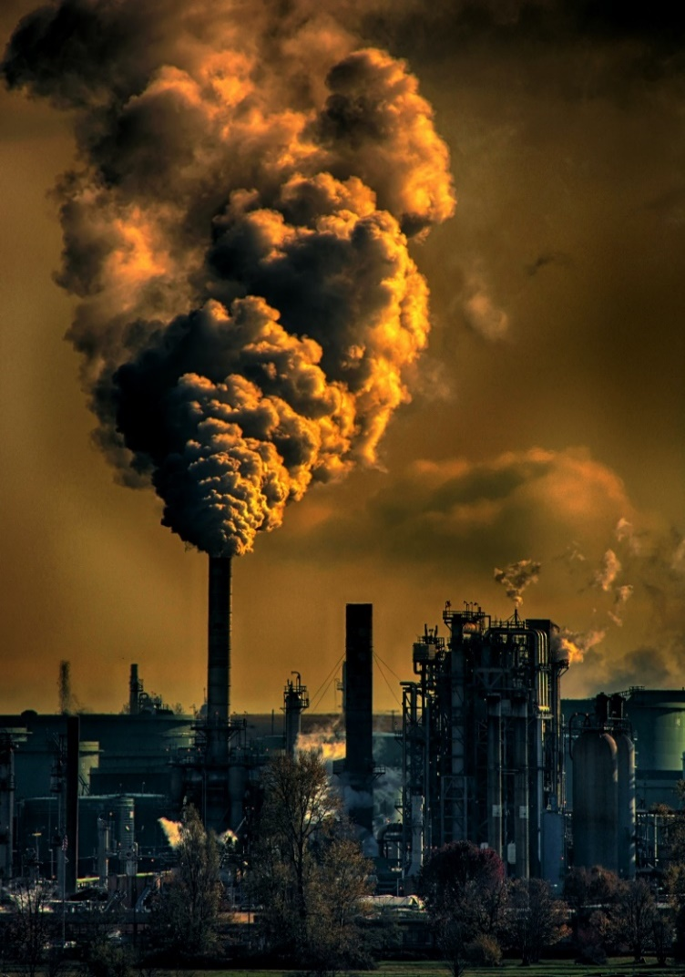Climate change: Many of the air pollutants emitted by the chemical industry, such as carbon dioxide and other greenhouse gases, contribute to global climate change.
* Acid rain: Sulfur dioxide emissions from the chemical industry can contribute to acid rain, which can have harmful effects on crops, forests, and waterways.
* Respiratory problems: Exposure to air pollution from the chemical industry can cause or exacerbate respiratory problems, including asthma and chronic obstructive pulmonary disease (COPD).
* Cancer: Exposure to certain air pollutants, such as benzene, can increase the risk of developing cancer.
* Neurological effects: Exposure to certain air pollutants, such as lead and mercury, can have adverse effects on the nervous system.

The chemical industry's operations can release large amounts of air pollutants, including sulfur dioxide, nitrogen oxides, volatile organic compounds, and particulate matter. These pollutants can cause serious health problems, including respiratory diseases, cardiovascular problems, and cancer. In addition, they contribute to climate change and damage ecosystems.

Air Pollution is the exoneration of unwanted materials and energy into the environment. Pollution is a sign of incompetence in industrial manufacturing and it can be considered as ejaculation of money from the chimney, thus causing huge loss to the producers. Major sources of air pollution in any industry are boiler, thermo pack and diesel generator which generate almost all types of pollutants those are listed in . Air emissions also include dust, acid vapors, oil mists and odours . Pharmaceutical industry emits more amount of iron into the atmosphere followed by copper and zinc; they are also the major sources of PM2.5 and PM10 emissions. Textile mills usually are the major sources of nitrogen and sulphur oxides from boiler . Fine chemicals industry also pour huge amount of toxic metals and harmful pollutants into the environment. High amounts of iron and copper are sent to the environment by this industry .

Dyeing industry is responsible for high amounts of lead emissions as well as PM10 and PM2.5 emissions. Oil & Surfactants industry, Metallurgical industry and Agrochemical industry are also responsible for release of toxic metals such as lead, nickel, copper and zinc and also lead to release of Sulphur dioxide (SO2) and Nitrogen dioxide (NO2).

It has been observed and proved that the emissions by these industries is adversely affecting the air quality and human health. It can be clearly observed from table 4 that the level of emission is much higher than the maximum tolerable limit standards stipulated by CPCB. These higher levels of toxicity in the atmosphere cause many health affects in human beings. Copper causes anemia, liver & kidney damage and many more diseases. Nickel causes heart disorder and lung embolism and much more. Lead is responsible for almost all the diseases that one can recall, from mental retardation to neural deafness and even also to death. Iron and Zinc also cause cancer and nervous membrane damage respectively. SO2 and NO2 are responsible for Nose & Throat irritation, respiratory illness, eyes irritation, etc

**5.Recommendation:**

There can be many methods that may be practiced which may help in absorbing toxic metals and harmful emissions around us without affecting the health. Physical methods may include the use of following:

* + - Cyclone Separator
    - Fabric Filter Baghouse
    - Lime/Limestone Wet Scrubbing System for Flue Gas Desulfurization
    - Electrostatic Precipitator
    - Oxidizer
    - Overhead pneumatic cleaners
    - Cloth filters
* **Use cleaner technologies and processes**: The chemical industry can use cleaner technologies and processes to reduce emissions of pollutants. For instance, the use of low-emission fuels, such as natural gas, can reduce the emission of sulfur dioxide and nitrogen oxides. In addition, the use of closed systems and process modifications can help to reduce emissions of volatile organic compounds.
* **Waste reduction and management**: Waste reduction and management practices can help to reduce the amount of pollutants generated by the chemical industry. This can include the implementation of recycling and reuse programs for waste products, as well as the use of pollution prevention measures to reduce waste generation.
* **Regulatory measures**: The government can implement regulatory measures to control air pollution from the chemical industry. This can include the establishment of emissions standards, mandatory reporting requirements, and penalties for non-compliance.
* **Public awareness and education campaigns**: Public awareness and education campaigns can help to raise awareness about the impacts of air pollution from the chemical industry. This can include educational programs for workers and the general public, as well as the dissemination of information about best practices for pollution prevention.
* **Collaboration**: Collaboration between the government, industry, and other stakeholders can help to identify solutions for reducing air pollution from the chemical industry. This can include the development of partnerships and joint initiatives to promote cleaner technologies and processes, waste reduction and management, and public awareness and education.

**6.CONCLUSION:**

The chemical industry's impact on air quality is a complex and ongoing issue. While the industry and government have taken steps to address the problem, there is still a long way to go to ensure that the industry operates in a safe and sustainable manner. Continued efforts to reduce emissions, invest in sustainable practices, and engage with local communities are crucial to mitigating the impact of the chemical industry on air quality and protecting public health and the environment.

